ADBUREAU ANALYTICS PRIVATE LIMITED
Internship Assignment #1 — Machine Learning Case Study
DIABETES READMISSION PREDICTION
A Predictive Analytics and Business Strategy Report
Identifying Patients at Risk of Hospital Readmission Before Discharge

Prepared by
Mithil Save
Tejas Sonawne
June 2026
Classification: Internal — Internship Deliverable

Table of Contents
Executive Summary3
1. Introduction5
2. Dataset Overview6
3. Exploratory Data Analysis8
4. Data Preparation and Feature Engineering15
5. Predictive Modeling Approach17
6. Model Evaluation19
7. Explainability and Risk-Driver Analysis22
8. Business Insights24
9. Business Recommendations26
10. Quantified Business Impact27
11. Limitations and Future Work29
12. Conclusion30

Executive Summary
Adbureau Analytics Private Limited undertook this engagement to determine whether routinely collected hospital data can identify, before a patient leaves the hospital, which patients with diabetes are likely to be readmitted. The analysis draws on a 10,000-encounter hospital dataset spanning demographics, diagnoses, medication history, laboratory activity, and prior utilization, and culminates in a tuned machine learning model intended to support discharge-planning decisions rather than replace clinical judgment.
The dataset shows that 39.65% of encounters (3,965 of 10,000) resulted in a readmission, a markedly higher base rate than is typical of unselected inpatient populations and a clear signal that readmission risk in this cohort is widespread rather than a tail event affecting only a small minority of patients. After excluding 256 encounters that ended in death or hospice discharge — patients who, by definition, cannot be readmitted — the remaining 9,744 encounters were used to train and evaluate seven machine learning algorithms and three ensemble strategies. The best-performing configuration, an F1-optimized Stacking Ensemble, achieves 59.06% accuracy, 49.77% precision, 82.45% recall, and a ROC-AUC of 0.691 on a held-out test set of 1,949 patients.
These figures fall short of the project's original 75% accuracy target, and this report does not understate that gap. What the analysis does demonstrate is that the model carries genuine, well-validated signal: it concentrates risk by roughly 1.26 times relative to the population average and, at its recall-optimized operating point, correctly flags 82.45% of patients who go on to be readmitted. In a discharge-planning context, where the cost of overlooking a high-risk patient (a missed intervention) generally exceeds the cost of one extra nurse review (a false alarm), a model tuned for recall is the more defensible operational choice, even though it is not the most accurate model in the comparison set.
The single most consistent finding across every method applied — univariate cross-tabulation, Pearson correlation, and machine-learned feature importance — is that prior healthcare utilization and diagnostic complexity predict readmission far more strongly than any marker of diabetes severity itself. Patients with at least one prior inpatient stay are readmitted at 55.9%, versus 34.4% for patients without one. Patients with seven or more coded diagnoses are readmitted at 45.1%, versus 31.1% for patients with fewer. By contrast, a primary diagnosis of diabetes itself carries a 41.0% readmission rate — close to the population average and not a standout risk marker. This reframes the operational question from “which patients have the worst diabetes” to “which patients have the most complex and recurrent care needs,” with direct implications for how discharge resources should be allocated.
Section 8 of this report sets out five business insights and Section 9 sets out five corresponding recommendations, each linked explicitly to its effect on clinical decision-making and on hospital operational efficiency. In combination, they support a phased deployment in which the model is used as a triage and prioritization layer within existing discharge workflows — directing nursing and care-coordination attention toward complex, high-utilization patients — rather than as an automated gatekeeping system.
Table 1. Key Results at a Glance
Metric | Value | Interpretation
Encounters Analyzed | 10,000 | Full raw dataset (51 features)
Population Readmission Rate | 39.65% | 3,965 of 10,000 encounters
Encounters Modeled (post-exclusion) | 9,744 | 256 expired/hospice encounters excluded
Selected Model | Stacking Ensemble (F1-Optimized) | Best balance of recall and discrimination
Model Accuracy | 59.06% | Below the 75% target; see Section 6.4
Model Recall (Sensitivity) | 82.45% | Share of true readmissions correctly flagged
Model Precision | 49.77% | Share of flagged patients who are truly readmitted
ROC-AUC | 0.691 | Moderate discriminative power
Risk Concentration (Lift) | ≈ 1.26x | Flagged patients vs. population average
Strongest Risk Driver | Prior Inpatient Stay | 55.9% vs. 34.4% readmission rate

1. Introduction

1.1 Business Background
Unplanned hospital readmissions are costly to hospitals, disruptive to patients, and, in many health systems, directly tied to regulatory and financial consequences. In the United States, for example, the Centers for Medicare & Medicaid Services (CMS) operates the Hospital Readmissions Reduction Program (HRRP), which reduces Medicare payments by up to 3% for hospitals with excess 30-day readmissions across a defined set of conditions. Beyond direct payment effects, every avoidable readmission also consumes a bed, a care team's time, and diagnostic capacity that could otherwise serve a new patient — making readmission reduction simultaneously a quality, financial, and capacity-management issue.
Diabetes is a particularly relevant condition for this kind of analysis because patients with diabetes frequently present with multiple coexisting conditions, complex medication regimens, and recurring contact with the health system. This makes them a high-value population for predictive discharge-planning tools: a model that can credibly flag elevated risk at the point of discharge gives care teams a window to intervene — through follow-up scheduling, medication reconciliation, or referral to care management — before a costly and avoidable return visit occurs.

1.2 Project Objective
The objective of this engagement was to build and evaluate a machine learning classifier capable of predicting the binary outcome variable readmitted (True/False) using information available at or before discharge. The intended use case is a discharge-time risk flag: a tool that helps care teams decide which patients warrant additional discharge planning, follow-up scheduling, or care-coordination resources, rather than a tool that makes clinical decisions on its own.

1.3 Scope and Methodology Overview
The analysis followed a standard applied data science workflow, executed in the following sequence:
- Exploratory data analysis of demographic, clinical, and utilization patterns across the full 10,000-encounter dataset.
- Data cleaning and feature engineering, including missing-value treatment, ICD-9 diagnosis grouping, and the construction of utilization- and comorbidity-based features.
- Training and tuning of seven classification algorithms, combined into three ensemble strategies, using randomized hyperparameter search under 5-fold cross-validation.
- Evaluation against accuracy, precision, recall, F1, and ROC-AUC, with decision-threshold optimization to address class imbalance.
- Feature-importance analysis to identify and interpret the model's principal risk drivers.
- Translation of the technical findings into business insights, recommendations, and a quantified view of operational impact, which together form the analytical core of this report.

2. Dataset Overview

2.1 Data Description
The source dataset contains 10,000 hospital encounters described by 51 features spanning patient demographics, admission and discharge details, diagnosis codes, medication activity, laboratory and procedure counts, and prior-utilization history. The target variable, readmitted, is a binary flag indicating whether the encounter was followed by a hospital readmission.
Table 2. Dataset Overview
Metric | Value
Total Encounters | 10,000
Total Features (raw) | 51
Target Variable | readmitted (True / False)
Readmitted (True) | 3,965 encounters (39.65%)
Not Readmitted (False) | 6,035 encounters (60.35%)
Native Missing-Value Rate | 3.94% of all cells (true nulls only)
Encounters Excluded Before Modeling | 256 (expired or hospice discharge)
Encounters Used for Modeling | 9,744
Feature categories present in the raw data include the following:
- Demographics: race, gender, age band, weight (largely unrecorded)
- Admission information: admission type, admission source, discharge disposition, time in hospital
- Diagnoses: up to three ICD-9 diagnosis codes per encounter, plus a count of total diagnoses coded
- Medication activity: usage and dosage-change status for eleven diabetes medications, plus a general medication-change flag
- Laboratory and procedure activity: number of lab procedures, number of procedures, A1C and glucose serum test results
- Prior utilization history: outpatient, emergency, and inpatient visit counts in the year preceding the encounter

2.2 Data Quality and Missing-Value Profile
Two distinct measures of missingness are relevant to this dataset, and the report distinguishes between them deliberately because they lead to different conclusions. The first is the rate of genuinely null (blank) cells in the source file, which averages 3.94% across all columns. The second, larger source of missing information is the placeholder value “?” used in several fields in place of a true null — most heavily in weight, glucose and A1C test results, and payer code. Table 3 reports column-level missingness treating both forms as missing, together with the action taken for each.
Table 3. Missing-Value Profile by Feature (Native Nulls and “?” Placeholders Combined)
Feature | % Missing | Action Taken
weight | 95.92% | Dropped (exceeds 50% threshold)
max_glu_serum | 93.36% | Dropped (exceeds 50% threshold)
A1Cresult | 83.79% | Dropped (exceeds 50% threshold)
payer_code | 53.41% | Dropped (exceeds 50% threshold)
medical_specialty | 41.00% | Retained; imputed as “Unknown” category
admission_source_id | 9.36% | Retained; mode-imputed
admission_type_id | 7.21% | Retained; mode-imputed
discharge_disposition_id | 4.69% | Retained; mode-imputed
race | 2.21% | Retained; mode-imputed
diag_3 | 2.08% | Retained; categorized as “Unknown”
diag_2 | 0.59% | Retained; categorized as “Unknown”
diag_1 | 0.02% | Retained; mode-imputed
Four columns exceeding the 50% missing-data threshold — weight, max_glu_serum, A1Cresult, and payer_code — were dropped outright rather than imputed, on the basis that imputing the majority of a column's values would manufacture signal rather than recover it. The remaining columns, including medical_specialty at 41% missing, were retained and either mode-imputed or assigned an explicit “Unknown” category, preserving the full encounter count rather than discarding partially complete records.

3. Exploratory Data Analysis
This section presents the descriptive analysis performed on the full 10,000-encounter dataset, prior to any of the cleaning or feature-engineering steps described in Section 4. Throughout this section, readmission rate figures are computed directly from the source data and are reported alongside each distribution so that demographic and clinical patterns can be read together with their associated risk.

3.1 Patient Demographics
The patient population is concentrated in older age bands, with a clear, almost monotonic increase in readmission rate as age increases — from 9.7% in the youngest band to a peak of 44.3% in the 80–89 age band. Gender, by contrast, shows almost no relationship with readmission: female patients are readmitted at 40.2% and male patients at 39.0%, a 1.2-percentage-point difference that is unlikely to be operationally meaningful.
Table 4. Patient Age Distribution and Associated Readmission Rate
Age Band | Patients | % of Total | Readmission Rate
0–10 | 31 | 0.3% | 9.7%
10–20 | 82 | 0.8% | 25.6%
20–30 | 143 | 1.4% | 30.8%
30–40 | 417 | 4.2% | 29.3%
40–50 | 978 | 9.8% | 35.3%
50–60 | 1,722 | 17.2% | 37.2%
60–70 | 2,187 | 21.9% | 40.5%
70–80 | 2,595 | 26.0% | 43.0%
80–90 | 1,577 | 15.8% | 44.3%
90–100 | 268 | 2.7% | 32.8%
Total | 10,000 | 100.0% | 39.65%
The 90–99 band is an exception to the otherwise rising trend, but it represents only 268 patients (2.7% of the dataset); a rate computed on such a small sample should be treated as indicative rather than statistically robust.
Table 5. Readmission Rate by Gender
Gender | Patients | % of Total | Readmission Rate
Female | 5,398 | 54.0% | 40.2%
Male | 4,602 | 46.0% | 39.0%
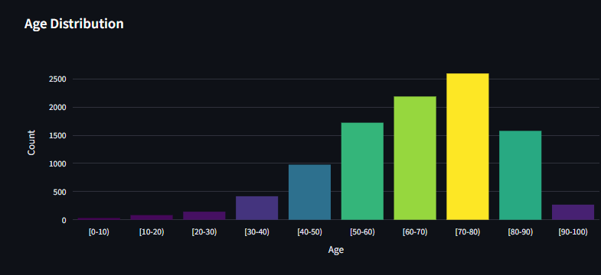
Figure 1. Age distribution of the patient population, by ten-year band. (Source: Project analytics dashboard)

3.2 Admission Patterns
Just under half of all encounters (49.1%) arrive through the Emergency admission pathway, far outnumbering Elective (17.9%) and Urgent (19.4%) admissions combined with the remaining categories. Readmission rates are modestly but consistently higher for unplanned admission routes: Emergency admissions readmit at 40.1%, versus 36.8% for Elective admissions — a real but moderate gap of 3.3 percentage points, smaller than the gaps associated with prior utilization or comorbidity (Section 3.3).
Table 6. Admission Type Distribution and Associated Readmission Rate
Admission Type | Patients | % of Total | Readmission Rate
Emergency | 4,905 | 49.1% | 40.1%
Urgent | 1,935 | 19.4% | 38.3%
Elective | 1,786 | 17.9% | 36.8%
Not Available | 614 | 6.1% | 34.5%
Not Mapped | 38 | 0.4% | 31.6%
Newborn | 1 | 0.0% | 0.0%
Total | 10,000 | 100.0% | 39.65%
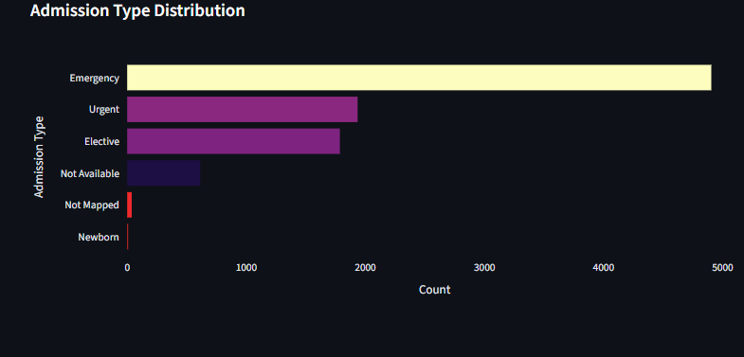
Figure 2. Distribution of encounters by admission type. (Source: Project analytics dashboard)

3.3 Readmission Risk by Key Segment
Figure 3 brings together five of the cross-tabulations computed in this section into a single comparative view, with a dashed reference line marking the 39.65% population average. Two patterns stand out immediately by the size of the gap they produce. Patients with at least one prior inpatient stay are readmitted at 55.9%, compared with 34.4% for patients with none — a 21.5-percentage-point gap, the largest of any segment examined. Patients with seven or more coded diagnoses (high comorbidity) are readmitted at 45.1%, compared with 31.1% for patients with fewer — a 14.0-percentage-point gap. By comparison, age, gender, and admission type each produce gaps of well under 15 percentage points across their respective categories. This is an important early signal, addressed in full in Section 7, that utilization history and clinical complexity are likely to dominate the model's eventual risk drivers.
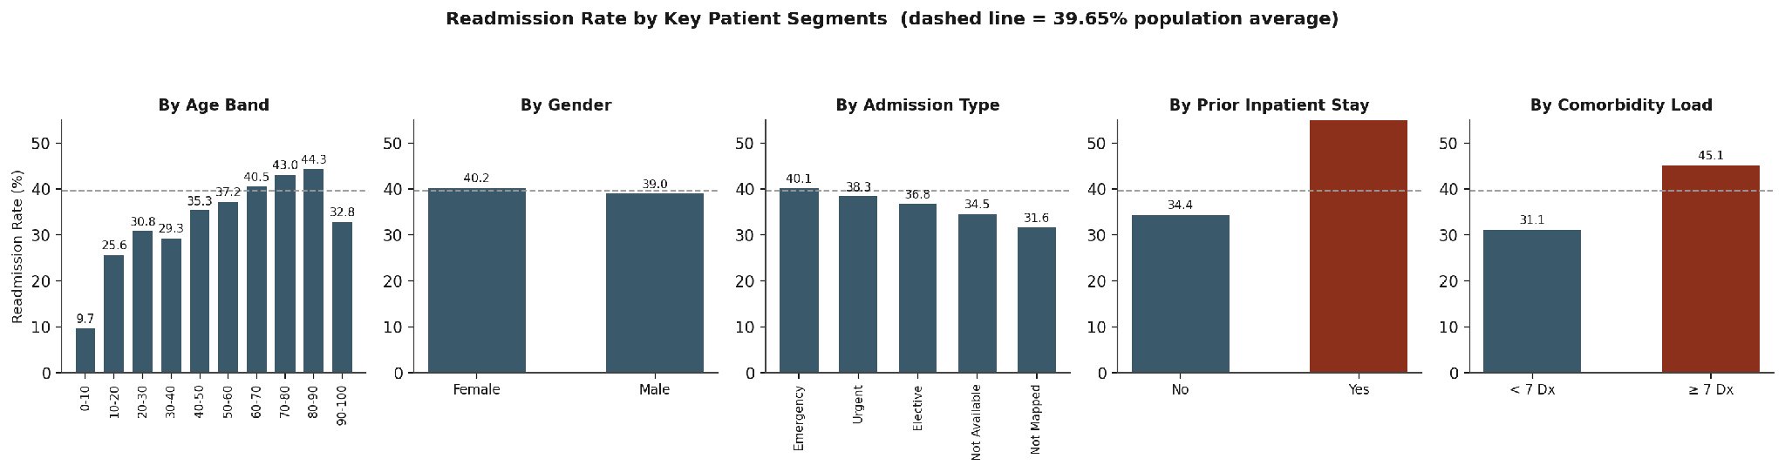
Figure 3. Readmission rate across five patient segments, with the population average (39.65%) shown as a reference line. (Source: Author's analysis of the underlying dataset)

3.4 Diagnosis Patterns
Primary diagnoses were grouped from their raw ICD-9 codes into nine clinical categories. Circulatory conditions are the single largest category, accounting for 31.93% of all encounters — nearly two and a half times the share of Diabetes itself as a primary diagnosis (8.46%). This confirms that the population is shaped as much by cardiovascular and other systemic comorbidity as by diabetes specifically. Readmission rates are relatively flat across most diagnosis categories, in the 36–42% range, with one clear exception: Neoplasms carry a markedly lower readmission rate of 25.6%, and Diabetes as a primary diagnosis sits almost exactly at the population average (41.0%) rather than standing out as a high-risk category.
Table 7. Primary Diagnosis Category Distribution and Associated Readmission Rate
Diagnosis Category | Patients | % of Total | Readmission Rate
Circulatory | 3,193 | 31.93% | 41.5%
Other | 1,756 | 17.56% | 40.2%
Respiratory | 1,324 | 13.24% | 40.4%
Digestive | 922 | 9.22% | 38.6%
Diabetes | 846 | 8.46% | 41.0%
Injury | 640 | 6.40% | 38.1%
Musculoskeletal | 521 | 5.21% | 36.5%
Genitourinary | 445 | 4.45% | 38.4%
Neoplasms | 351 | 3.51% | 25.6%
Unknown | 2 | 0.02% | 50.0% (n=2)
Total | 10,000 | 100.00% | 39.65%
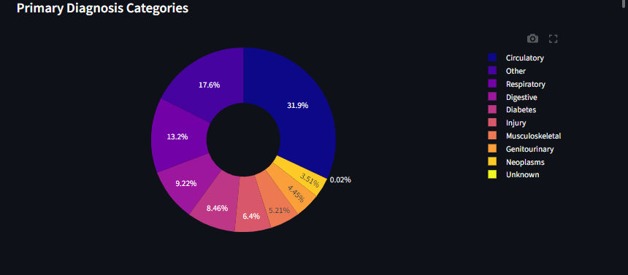
Figure 4. Distribution of primary diagnosis by clinical category. (Source: Project analytics dashboard)

3.5 Medication Utilization
Insulin is by far the most frequently prescribed diabetes medication, appearing in 48.4% of all encounters — more than double the next most common agent, Metformin (19.9%). This pattern is consistent with a population that includes a substantial share of insulin-dependent or advanced-stage patients, and is corroborated by the high average medication count per encounter (15.6 medications, Section 3.6).
Table 8. Active Prescriptions by Diabetes Medication
Medication | Patients Prescribed | % of Total Encounters
Insulin | 4,841 | 48.4%
Metformin | 1,989 | 19.9%
Glipizide | 1,304 | 13.0%
Glyburide | 1,186 | 11.9%
Rosiglitazone | 761 | 7.6%
Pioglitazone | 706 | 7.1%
Glimepiride | 491 | 4.9%
Repaglinide | 130 | 1.3%
Nateglinide | 51 | 0.5%
Acarbose | 32 | 0.3%
Miglitol | 5 | 0.1%
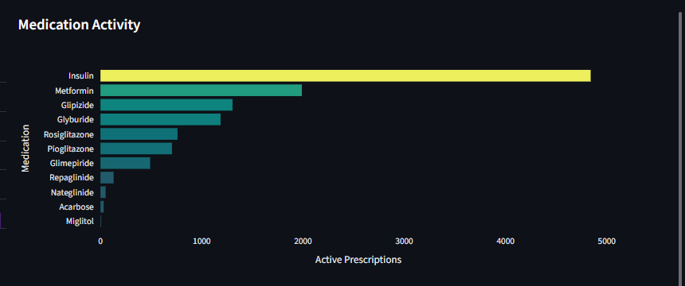
Figure 5. Active prescription counts across the eleven diabetes medications recorded in the dataset. (Source: Project analytics dashboard)

3.6 Correlation Analysis
Figure 6 presents the Pearson correlation matrix for the dataset's core numeric features alongside the binary readmission target. Two findings from this purely linear analysis anticipate the machine-learned feature-importance results in Section 7. Number of prior inpatient visits (r = 0.195) and number of diagnoses coded (r = 0.156) are the two features most strongly correlated with readmission — noticeably ahead of laboratory activity, emergency visits, outpatient visits, length of stay, and medication count, all of which fall between r = 0.04 and r = 0.08. Number of procedures performed shows a small negative correlation with readmission (r = − 0.03), suggesting that more procedurally intensive stays are, if anything, marginally less likely to be followed by a readmission — plausibly because such stays more often resolve the presenting problem definitively.
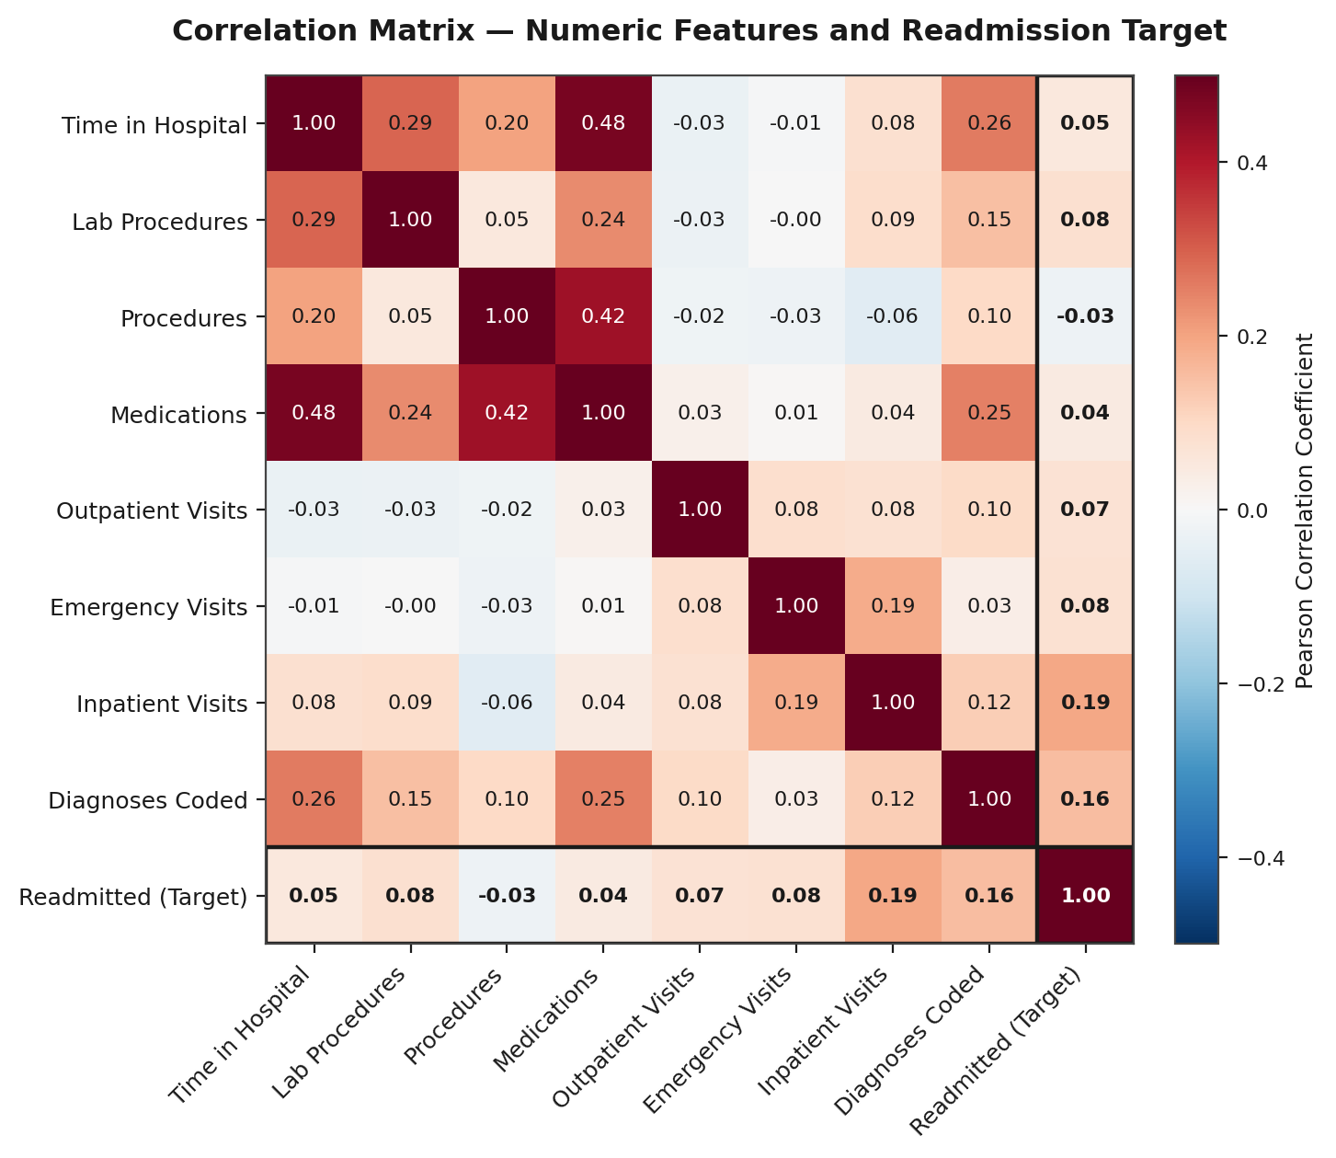
Figure 6. Pearson correlation matrix for numeric utilization and clinical features against the readmission target. (Source: Author's analysis of the underlying dataset)

3.7 Hospitalization and Utilization Summary Statistics
Table 9 summarizes the central tendency and spread of the dataset's core numeric features. The patient population averages 4.43 days per stay, 15.56 medications, and 43.08 lab procedures per encounter — indicative of a clinically complex population rather than a population of short, routine admissions.
Table 9. Descriptive Statistics — Core Numeric Features (n = 10,000)
Metric | Mean | Std. Dev. | Median | Min | Max
Time in Hospital (days) | 4.43 | 3.02 | 4 | 1 | 14
Lab Procedures | 43.08 | 19.45 | 44 | 1 | 120
Procedures Performed | 1.40 | 1.71 | 1 | 0 | 6
Medications Administered | 15.56 | 8.39 | 14 | 1 | 81
Outpatient Visits (prior yr.) | 0.28 | 1.12 | 0 | 0 | 36
Emergency Visits (prior yr.) | 0.12 | 0.65 | 0 | 0 | 42
Inpatient Visits (prior yr.) | 0.39 | 0.85 | 0 | 0 | 10
Diagnoses Coded | 7.03 | 2.02 | 7 | 1 | 9

3.8 Summary of Exploratory Findings
- Readmission risk rises steadily with age, with no meaningful difference by gender.
- Emergency admissions are the dominant entry pathway and carry a modest but consistent readmission premium over planned admissions.
- Prior inpatient history and diagnostic complexity (comorbidity) produce far larger readmission-rate gaps than any demographic or admission-route variable.
- Cardiovascular (Circulatory) conditions, not diabetes itself, are the leading primary diagnosis in this population; diabetes as a primary diagnosis carries an average, not elevated, readmission rate.
- Insulin dependence is widespread, and overall medication and lab-procedure intensity point to a clinically complex patient population.
- Linear correlation and, later, machine-learned feature importance both converge on prior utilization and comorbidity as the leading quantitative risk signals — a finding that directly motivates the feature-engineering choices described in Section 4.

4. Data Preparation and Feature Engineering

4.1 Cohort Definition
Before any feature engineering, 256 encounters with a discharge disposition of Expired, Hospice / Home, or Hospice / Medical Facility were removed from the modeling cohort. These patients cannot, by definition, be readmitted, and their inclusion would have introduced a structural source of negative-class noise unrelated to genuine readmission risk. This reduced the working dataset from 10,000 to 9,744 encounters, which were then split 80/20 into training (7,795 encounters) and test (1,949 encounters) sets using stratified sampling to preserve the target's class balance in both partitions.

4.2 Missing-Value Treatment
The missing-value strategy followed the profile established in Section 2.2: the four columns exceeding 50% missingness (weight, max_glu_serum, A1Cresult, payer_code) were dropped; medical_specialty, despite 41% missingness, was retained and given an explicit “Unknown” category rather than dropped or imputed, since its absence later proved to carry independent predictive signal (Section 7); and the remaining low-missingness categorical columns were mode-imputed.

4.3 Feature Engineering
A total of twenty-plus engineered features were added to the raw feature set, organized into five groups described below and summarized in Table 10.

Utilization and Comorbidity Features
Three prior-utilization counts (outpatient, emergency, and inpatient visits) were summed into a single prior_visits score, with a high_utilizer flag for patients scoring three or more. A has_prior_inpatient binary flag and an inpatient_squared term were added to let the model capture both the presence and the magnitude of prior inpatient history. A high_comorbidity flag marks patients with seven or more coded diagnoses, directly operationalizing the segment analysis in Section 3.3.

Diagnosis Recoding
All three diagnosis fields (diag_1, diag_2, diag_3) were converted from raw ICD-9 codes into the nine clinical categories used throughout Section 3, with the original high-cardinality codes (several hundred distinct values) dropped in favor of the interpretable grouping. Binary flags were also added for a Circulatory or Diabetes primary diagnosis specifically.

Clinical Severity Encoding
A1C test results and maximum glucose serum readings were converted from their categorical bands into ordinal scales reflecting increasing clinical severity, with companion binary flags for clinically abnormal results. Medication change indicators across all eleven diabetes medications were similarly encoded on a meaningful 0–3 ordinal scale (No activity, Steady, Decreased, Increased) rather than treated as unordered categories.

Interaction and Intensity Features
Six interaction terms were constructed to capture compounding effects between utilization and clinical complexity — for example, meds_x_inpatient (medication count multiplied by inpatient visit count) and diag_x_inpatient (diagnosis count multiplied by inpatient visit count). Two intensity ratios, labs_per_day and meds_per_day, normalize lab and medication activity by length of stay.

Patient Archetypes (Unsupervised Segmentation)
After all other features were one-hot encoded, a K-Means clustering step (five clusters) was fitted on the standardized training feature matrix to generate five archetype_0 through archetype_4 membership flags. This unsupervised step lets the model draw on multidimensional patient-profile groupings that are not reducible to any single engineered variable, and two of these archetypes — archetype_3 and archetype_4 — appear among the model's leading predictors in Section 7. All encoding, including one-hot expansion and clustering, was fitted strictly after the train/test split to prevent target leakage.
Table 10. Feature Engineering Summary
Feature | Definition | Rationale
age_numeric | Ordinal mapping of the ten age bands to 0–9 | Converts an ordered category into a usable numeric scale
prior_visits | Sum of outpatient, emergency, and inpatient visit counts | Single combined measure of recent healthcare utilization
high_utilizer | Flag: prior_visits ≥ 3 | Identifies frequent-utilization patients
has_prior_inpatient | Flag: number_inpatient > 0 | Isolates patients with any inpatient history
high_comorbidity | Flag: number_diagnoses ≥ 7 | Identifies multi-condition, high-complexity patients
diag_1/2/3_category | ICD-9 codes grouped into 9 clinical categories | Converts 700+ raw codes into an interpretable grouping
A1C_ordinal / A1C_abnormal | Ordinal encoding of A1C result, plus abnormality flag | Reflects glycemic control severity
medication_changed | Flag: any diabetes medication dosage changed | Signals an acute in-stay medication adjustment
meds_x_inpatient, diag_x_inpatient, etc. | Six pairwise interaction terms | Captures compounding utilization × complexity effects
archetype_0 – archetype_4 | K-Means (k=5) cluster membership on the full feature set | Captures latent multidimensional patient profiles

5. Predictive Modeling Approach

5.1 Algorithms Evaluated
Seven classification algorithms were trained and independently tuned: XGBoost, LightGBM, CatBoost, Random Forest, Extra Trees, Gradient Boosting, and Logistic Regression. Each algorithm was tuned using RandomizedSearchCV with 80 search iterations under 5-fold cross-validation, scored on ROC-AUC. Table 11 summarizes the hyperparameter search space for each algorithm.
Table 11. Algorithms Evaluated and Hyperparameter Search Space
Algorithm | Key Hyperparameters Tuned
XGBoost | n_estimators (200–600), max_depth (4–10), learning_rate (0.02–0.20), subsample, colsample_bytree, min_child_weight, gamma
LightGBM | n_estimators (100–400), max_depth (4–10), learning_rate, num_leaves (20–100), subsample, colsample_bytree, reg_alpha, reg_lambda
CatBoost | iterations (100–400), depth (4–8), learning_rate, subsample, l2_leaf_reg
Random Forest / Extra Trees | n_estimators (100–300), max_depth (5–20), min_samples_split, min_samples_leaf, max_features
Gradient Boosting | Standard scikit-learn boosting parameter grid
Logistic Regression | Regularization strength, tuned under the same search protocol

5.2 Ensemble Strategies
Three ensembling layers were built on top of the seven tuned base models:
- Voting Ensemble — averages the predicted probabilities of the base models.
- Stacking Ensemble — trains a meta-model on out-of-fold predictions from the base models using 5-fold cross-validation, allowing the ensemble to learn how to weight each base model's output rather than averaging them uniformly.
- Blending (Super Learner) — directly optimizes a weighted blend of base-model probabilities by minimizing the negative F1 score on a validation split.
As shown in Section 6.1, the Stacking Ensemble and the Blending model converged on effectively identical performance, suggesting that the two approaches discovered a similar combination of base-model strengths.

5.3 Addressing Class Imbalance
With a 39.65% positive rate, the dataset is imbalanced enough that a model optimized purely for accuracy can perform well by under-predicting the minority (readmitted) class — a failure mode that would be operationally useless, since the entire purpose of the model is to catch true readmissions. Two complementary techniques were used to counter this:
- SMOTE (Synthetic Minority Over-sampling Technique, k=5 neighbors) was applied to the training set only, never to the test set, to avoid leaking synthetic patterns into the evaluation.
- Decision-threshold optimization was performed independently for each model by scanning the precision-recall curve and selecting the threshold that maximizes the F1 score, rather than using the conventional default of 0.5. This single step is responsible for the substantial recall gains documented in Section 6.

6. Model Evaluation

6.1 Comparative Model Performance
Table 12 reports F1-optimized performance for all ten trained configurations on the 1,949-patient held-out test set. The Stacking Ensemble and the Blending (Super Learner) model are statistically tied for best overall performance, both achieving 59.06% accuracy, 49.77% precision, 82.45% recall, an F1 score of 62.07%, and a ROC-AUC of 0.6913. The Stacking Ensemble was selected as the production candidate on the basis of its more principled meta-learning mechanism.
Table 12. Comparative Model Performance — F1-Optimized Decision Threshold (Test Set, n = 1,949)
Model | Accuracy | Precision | Recall | F1 Score | ROC-AUC
Extra Trees | 53.16% | 46.21% | 93.06% | 61.75% | 0.6833
LightGBM | 54.49% | 46.89% | 90.53% | 61.78% | 0.6872
Gradient Boosting | 54.64% | 46.97% | 89.90% | 61.70% | 0.6881
Logistic Regression | 56.39% | 48.00% | 87.88% | 62.09% | 0.6788
XGBoost | 56.08% | 47.79% | 87.50% | 61.82% | 0.6874
Random Forest | 57.26% | 48.49% | 83.21% | 61.27% | 0.6780
Weighted Voting | 58.49% | 49.36% | 82.83% | 61.86% | 0.6908
Blending (Super Learner) | 59.06% | 49.77% | 82.45% | 62.07% | 0.6913
Stacking Ensemble (Selected) | 59.06% | 49.77% | 82.45% | 62.07% | 0.6913
Voting Ensemble | 58.95% | 49.69% | 81.94% | 61.87% | 0.6909
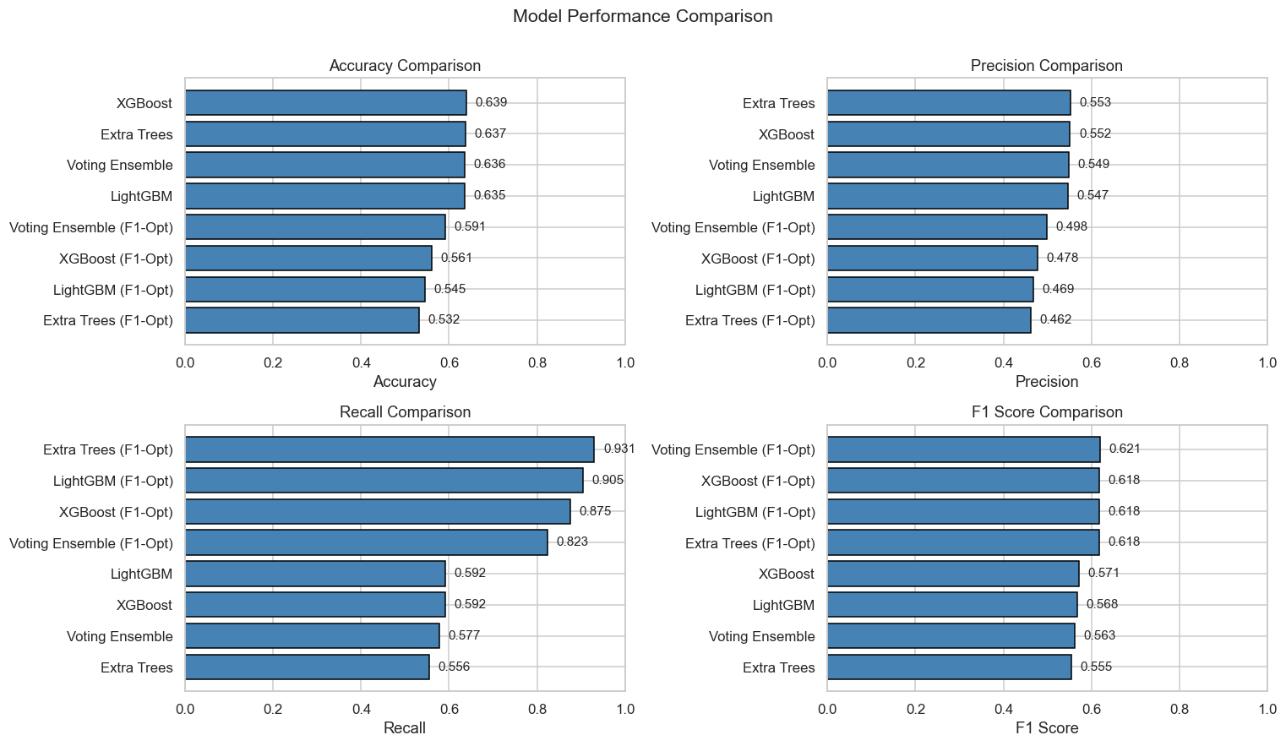
Figure 7. Accuracy, precision, recall, and F1 score across both default-threshold and F1-optimized variants of four representative algorithms. (Source: Project model-evaluation pipeline)

6.2 Confusion Matrix Analysis
Table 13 details the confusion matrix for XGBoost at its conventional 0.5 decision threshold (rather than the F1-optimized threshold used in Table 12), to illustrate the trade-off that threshold optimization is designed to correct. At this default threshold, the model correctly identifies 469 of 792 true readmissions (59.22% recall) and 776 of 1,157 true non-readmissions (67.07% specificity), for an overall accuracy of 63.88% and an F1 score of 57.13%.
Table 13. XGBoost Confusion Matrix — Default 0.5 Threshold (Test Set, n = 1,949)
 | Predicted: Not Readmitted | Predicted: Readmitted | Total (Actual)
Actual: Not Readmitted | 776 (True Negative) | 381 (False Positive) | 1,157
Actual: Readmitted | 323 (False Negative) | 469 (True Positive) | 792
Total (Predicted) | 1,099 | 850 | 1,949
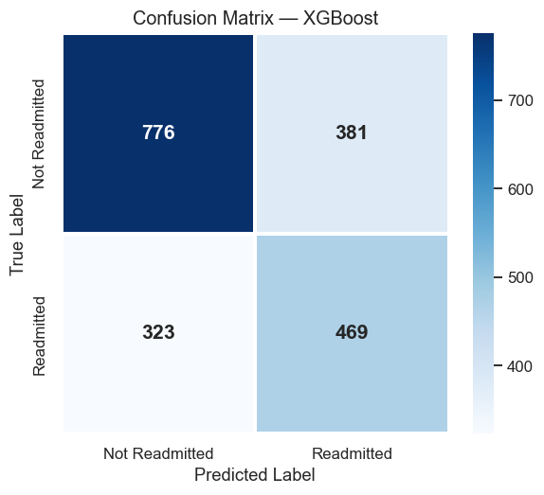
Figure 8. Confusion matrix for XGBoost at the default 0.5 classification threshold. (Source: Project model-evaluation pipeline)

6.3 ROC Curve Analysis
XGBoost achieves a ROC-AUC of 0.687, indicating discrimination meaningfully better than chance (0.500) but well short of excellent (typically 0.80 and above). The curve in Figure 9 shows the model performing best in the low-to-moderate false-positive-rate range, which is the operating region most relevant to a discharge-screening use case, where flagging a large share of all discharges as high-risk would defeat the purpose of triage.
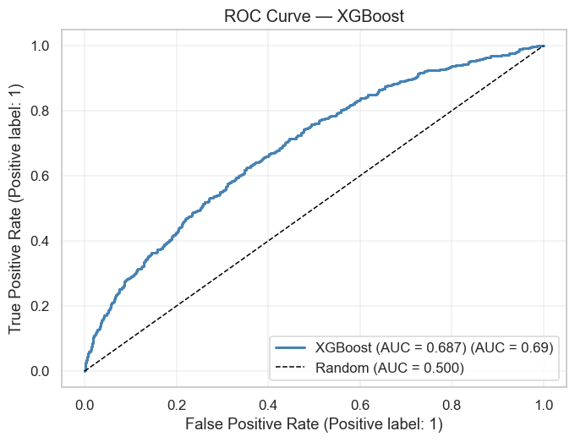
Figure 9. ROC curve for XGBoost at default threshold (AUC = 0.687). (Source: Project model-evaluation pipeline)

6.4 Model Selection Rationale: Accuracy Versus Recall
The project's original target was 75% accuracy and 80% ROC-AUC. The achieved Stacking Ensemble reaches 59.06% accuracy and 0.691 ROC-AUC — short of both targets, and this report states that gap plainly rather than obscuring it. The relevant question for deployment, however, is not simply which model scores highest on accuracy, but which model best serves the discharge-screening use case.
Accuracy is a poor optimization target for an imbalanced, asymmetric-cost problem of this kind. A hospital using this model to screen discharges is far more concerned with recall — the share of true readmissions the model successfully flags — than with overall accuracy, because a missed high-risk patient (a false negative) represents a lost opportunity to intervene, while an extra nurse review of a flagged patient who was not, in fact, going to be readmitted (a false positive) carries a comparatively small cost. Moving from the default-threshold XGBoost model (63.88% accuracy, 59.22% recall) to the F1-optimized Stacking Ensemble (59.06% accuracy, 82.45% recall) trades roughly 5 accuracy points for more than 23 recall points — a trade this report regards as the correct operational choice for a screening tool, even though it is not the choice that maximizes the single headline accuracy figure.

7. Explainability and Risk-Driver Analysis

7.1 Feature Importance Analysis
Figure 10 presents the top twenty feature importances from the trained XGBoost model. Table 14 lists the ten leading features with approximate importance scores read from the trained-model visualization (an exact exported importance table was not available in the project's evaluation pipeline, so these values should be read as indicative rankings rather than precise statistics).
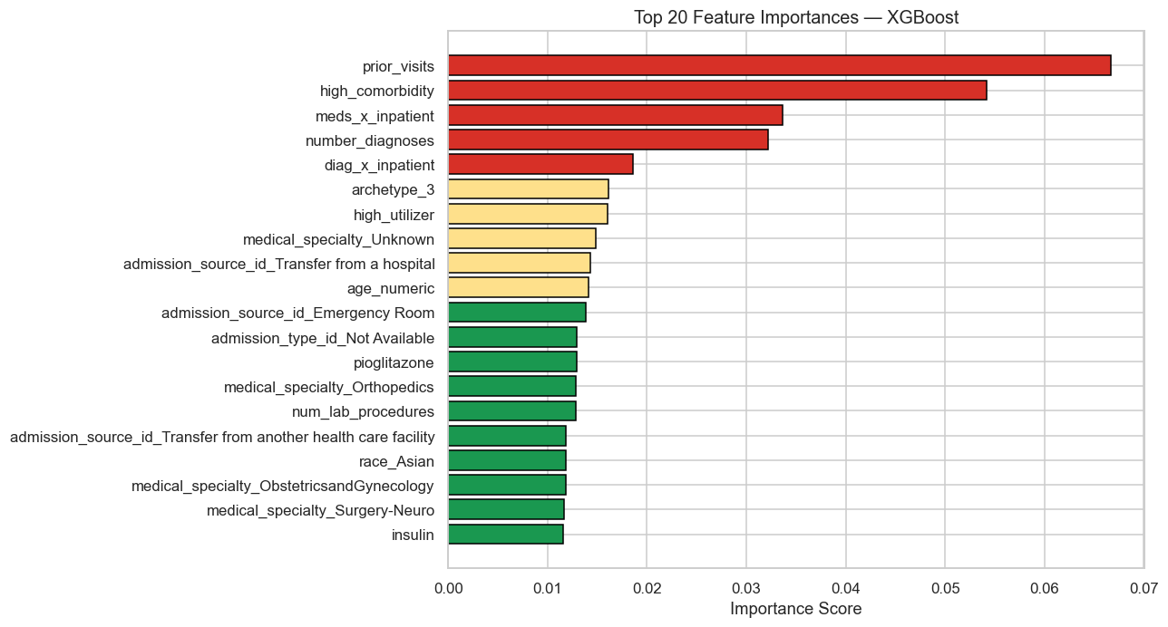
Figure 10. Top twenty feature importances, XGBoost. Color denotes importance tier (red = highest). (Source: Project model-evaluation pipeline)
Table 14. Leading Feature Importances (XGBoost, Approximate Values)
Rank | Feature | Approx. Importance | Interpretation
1 | prior_visits | 0.067 | Cumulative outpatient / emergency / inpatient utilization
2 | high_comorbidity | 0.054 | Flag for seven or more coded diagnoses
3 | meds_x_inpatient | 0.034 | Medication load during prior inpatient stays
4 | number_diagnoses | 0.032 | Raw count of coded diagnoses
5 | diag_x_inpatient | 0.019 | Diagnosis-count × inpatient-visit interaction
6 | archetype_3 | 0.016 | Unsupervised K-Means patient segment
7 | high_utilizer | 0.016 | Flag for 3+ combined prior visits
8 | medical_specialty_Unknown | 0.015 | Missing attending-specialty documentation
9 | admission_source_id_Transfer | 0.014 | Inter-facility transfer as admission origin
10 | age_numeric | 0.014 | Patient age band

7.2 Interpretation of Key Risk Drivers
Three converging analyses — the univariate segment comparison in Section 3.3, the linear correlation matrix in Section 3.6, and the machine-learned feature importances above — all point to the same conclusion: prior healthcare utilization and diagnostic complexity dominate the model's risk signal, well ahead of any single demographic factor or diabetes-specific clinical marker. The top five features by importance are all utilization- or complexity-related; the first feature with a demographic character (age_numeric) does not appear until rank ten.
This has a direct and somewhat counter-intuitive implication for how readmission risk should be understood operationally: the model is not, in any meaningful sense, identifying “patients whose diabetes is poorly controlled.” It is identifying patients whose overall care history is complex and recurrent. A patient with well-controlled diabetes but a recent inpatient stay for an unrelated cardiac event will score as higher-risk than a patient with poor glycemic control but no recent hospital contact.

7.3 Counter-Intuitive and Noteworthy Findings
- Diabetes severity is not a leading driver. None of the direct glycemic-control markers (A1C result, glucose serum result, insulin usage) rank among the top ten features, and Section 3.4 shows that a primary diagnosis of diabetes itself carries an average, not elevated, readmission rate (41.0% versus a 39.65% population average). The operative risk factor is care complexity, not diabetic severity per se.
- Missing specialty documentation carries real signal. medical_specialty_Unknown — effectively a data-quality gap, since it flags encounters where the attending physician's specialty was not recorded — ranks eighth in importance. This suggests that incomplete documentation at admission is itself correlated with higher-risk, less-specialized care pathways, rather than being random noise.
- Unsupervised patient archetypes add explanatory value beyond engineered features. Two of the five K-Means-derived archetype flags (archetype_3 and, to a lesser extent, archetype_4) rank among the model's leading predictors, indicating that some risk-relevant patient profiles are genuinely multidimensional and are not fully captured by any single hand-engineered variable.
- Inter-facility transfers are a meaningful admission-source signal. Patients transferred in from another hospital rank ninth in importance, ahead of most demographic variables — plausibly reflecting that transferred patients are, on average, more medically complex than walk-in or self-referred admissions.

8. Business Insights
This section translates the analytical findings of Sections 3, 6, and 7 into five business insights, each stated with its supporting evidence and then traced explicitly to its implications for clinical decision-making and for hospital operational efficiency. Table 15 summarizes all five; the discussion that follows expands on each in turn.
Table 15. Business Insights and Their Clinical and Operational Implications
# | Insight | Supporting Evidence | Clinical Decision-Making Impact | Operational Efficiency Impact
1 | Utilization history outweighs diagnosis severity | prior_visits and inpatient-related features rank above every diabetes-severity marker (Sec. 7.1) | Shifts discharge-risk review from “how severe is the diabetes” to “how complex is the care history” | Lets care teams prioritize chart review by utilization pattern rather than re-reading full diagnostic history
2 | Comorbidity load is a major risk multiplier | 45.1% vs. 31.1% readmission rate, high vs. low comorbidity (Sec. 3.3) | Flags multi-diagnosis patients for broader discharge planning, not single-condition follow-up | Targets case-management capacity at the ~61% of patients with 7+ diagnoses, not the full population
3 | Unplanned admissions carry a real, moderate risk premium | 40.1% (Emergency) vs. 36.8% (Elective) readmission rate (Sec. 3.2) | Signals that ER-admitted patients may lack an existing care plan and need one built during the stay | Supports earlier engagement of discharge planners for ER admissions, before the day of discharge
4 | Readmission is a high-frequency, not tail, event | 39.65% population base rate (Sec. 2.1) | Discharge risk review should be a standard step for most patients, not an exception process | Justifies investment in a systematic screening workflow rather than ad hoc case-by-case review
5 | Documentation gaps coincide with elevated risk | medical_specialty_Unknown ranks 8th in feature importance (Sec. 7.3) | Encourages closing specialty documentation gaps as part of admission quality, not just data hygiene | Improves both model accuracy and downstream specialist-referral routing at the same time

8.1 Insight 1 — Utilization History Outweighs Diagnosis Severity
Across every analytical method applied in this report, prior healthcare utilization — not diabetes severity — is the strongest predictor of readmission. This is a genuinely actionable reframing for clinical teams: a patient's discharge-risk conversation should foreground their recent inpatient and emergency contact history at least as prominently as their current glycemic control.

8.2 Insight 2 — Comorbidity Load Is a Major Risk Multiplier
With 61% of the population coded with seven or more diagnoses, and that group carrying a 45.1% readmission rate versus 31.1% for lower-comorbidity patients, comorbidity-aware discharge planning has the potential to touch a majority of the patient population, not a narrow subgroup.

8.3 Insight 3 — Unplanned Admissions Carry a Real, Moderate Risk Premium
The gap between Emergency and Elective admission readmission rates (3.3 percentage points) is real but modest — smaller than either the prior-inpatient gap or the comorbidity gap. Admission route should therefore be treated as a secondary, supporting signal rather than a primary triage criterion on its own.

8.4 Insight 4 — Readmission Is a High-Frequency, Not Tail, Event
At a 39.65% base rate, readmission risk review cannot realistically be treated as an exception process reserved for a handful of obviously fragile patients. The scale of the problem supports building a standard, systematic screening step into the discharge workflow for the majority of admissions.

8.5 Insight 5 — Documentation Gaps Coincide With Elevated Risk
The independent predictive value of medical_specialty_Unknown suggests that incomplete admission documentation is not random; it appears to travel with less specialized, higher-risk care pathways. Improving documentation practice is therefore a quality initiative with a measurable analytical payoff, not merely an administrative housekeeping task.

9. Business Recommendations
The five recommendations below correspond directly to the five insights in Section 8 and are intended to be actioned by hospital operations and clinical leadership jointly, since each combines a clinical workflow change with an operational resourcing decision.
Table 16. Recommendations, Ownership, and Expected Effect
# | Recommendation | Primary Owner | Expected Effect
1 | Deploy the model as a discharge-time triage flag that routes high-risk patients to a nurse-led case review, not as an automated gatekeeper that blocks discharge | Care Management / Nursing Leadership | Directs limited review capacity to the patients most likely to benefit, without overriding clinical judgment
2 | Build a structured transition-of-care track for high-utilization patients: a 48–72 hour post-discharge follow-up call plus a scheduled 7-day primary-care visit | Discharge Planning / Care Coordination | Targets the 21.5-point risk gap associated with prior inpatient history (Sec. 3.3) with a concrete, schedulable intervention
3 | Engage discharge planners earlier — at admission rather than at the point of discharge — for patients arriving through the Emergency pathway | Emergency Department / Discharge Planning | Closes the planning-time gap that likely contributes to the Emergency-vs-Elective readmission differential
4 | Make medical-specialty capture a required admission-documentation field, with a brief audit of “Unknown” encounters | Health Information Management / Medical Records | Improves both model input quality and downstream specialist-referral accuracy
5 | Operate the model at a recall-favoring threshold in production, and review the operating threshold periodically against care-management capacity | Data Science / Clinical Informatics | Keeps the false-negative rate (missed high-risk patients) low, which this report treats as the costlier error type

9.1 Implementation Sequencing
Recommendations 1 and 5 are prerequisites for the others, since they establish the basic mechanism (a working risk flag, operating at an appropriate threshold) that Recommendations 2 through 4 then act upon. A pragmatic sequencing is to pilot Recommendation 1 on a single ward or service line, validate that flagged patients do, in fact, readmit at a materially higher rate than unflagged patients in live operation (not just in the held-out test set), and only then extend the transition-of-care track (Recommendation 2) and the earlier ED-engagement workflow (Recommendation 3) hospital-wide.

10. Quantified Business Impact

10.1 Risk Concentration and Screening Yield
At its F1-optimized operating threshold, the Stacking Ensemble flags approximately 65.7% of all discharges as high-risk — a figure derived directly from the model's own precision and recall (recall × base rate ÷ precision). Within that flagged group, the true readmission rate is 49.77%, against a population average of 39.65%. This represents a risk concentration, or lift, of approximately 1.26 times the population average: a flagged patient is roughly one-quarter more likely to be readmitted than an average discharge, and the flagged group captures 82.45% of all patients who will actually be readmitted.
This is a deliberately recall-favoring operating point, consistent with the rationale in Section 6.4. Hospitals with constrained care-management capacity may choose to operate the same model at a stricter threshold, trading some recall for a narrower, higher-precision flag list; the analysis in this report establishes the model's discriminative validity, and the specific operating threshold should be set jointly by clinical and operations leadership based on available follow-up capacity, rather than fixed unilaterally by the model.
Table 17. Quantified Impact Metrics at the Selected Operating Point
Metric | Value | Interpretation
Population Base Rate | 39.65% | Readmission rate across all discharges
Flagged-Group Precision | 49.77% | Readmission rate among patients flagged as high-risk
Risk Concentration (Lift) | ≈ 1.26x | Flagged patients vs. an average, unscreened discharge
Recall at Selected Threshold | 82.45% | Share of true readmissions the model successfully flags
Approx. Share of Discharges Flagged | ≈ 65.7% | Derived from recall × base rate ÷ precision
Specificity (Default Threshold, XGBoost) | 67.07% | Share of true non-readmissions correctly cleared

10.2 Cost and Regulatory Context
While this engagement did not have access to hospital-specific cost data, the broader regulatory environment for readmissions provides useful context for interpreting the model's value. In the United States, the CMS Hospital Readmissions Reduction Program reduces Medicare payments by up to 3% for hospitals with excess 30-day readmissions across a defined set of conditions — a direct financial consequence layered on top of the operational cost of an avoidable readmission (an occupied bed, a care team's time, and diagnostic capacity that could otherwise serve a new patient). A model that helps a hospital direct follow-up resources toward the patients identified in Section 8 as carrying the largest readmission-rate gaps — those with prior inpatient stays and high comorbidity counts — is most directly relevant to reducing exposure under this kind of program, even though this report does not attempt to estimate a specific dollar figure without hospital-specific financial data.

10.3 Implications for Clinical Decision-Making
The model is best understood as a second opinion at the point of discharge, surfacing utilization and complexity patterns that may not be immediately salient to a care team focused on the patient's presenting condition. It does not replace clinical judgment: a 49.77% flagged-group precision means that, on average, roughly one in two flagged patients will not, in fact, be readmitted, so a flag should prompt a structured review rather than an automatic action. Used this way, the model's primary clinical value is in directing attention — ensuring that high-utilization, high-comorbidity patients are not discharged without a deliberate transition-of-care conversation, rather than determining clinical decisions outright.

10.4 Implications for Hospital Operational Efficiency
Operationally, the model converts an undifferentiated discharge population into a risk-ranked one, which is the precondition for any form of targeted resource allocation. Concentrating post-discharge follow-up call capacity, care-coordinator time, and expedited primary-care scheduling on the highest-risk segments identified in Section 8 — rather than spreading the same resources evenly across all discharges — is the direct operational consequence of the 1.26x risk concentration documented above. Because the underlying risk drivers (prior utilization, comorbidity count) are already captured in most electronic health record systems, the marginal cost of generating the risk flag itself is low relative to the cost of the clinical follow-up actions it would direct.

11. Limitations and Future Work
- Accuracy and AUC below target. The selected model's 59.06% accuracy and 0.691 ROC-AUC fall short of the project's 75% and 0.80 targets respectively. The model should be positioned as a triage aid with demonstrated, moderate-strength signal, not as a high-confidence diagnostic tool.
- Single-institution, historical dataset. All findings are derived from one 10,000-encounter dataset. Coding practices, patient mix, and care protocols vary across hospitals, and the model's coefficients and thresholds should be re-validated before deployment at any institution other than the one that generated this data.
- Approximate feature-importance values. The importance scores in Table 14 were read from a saved visualization rather than an exported numeric table, and should be treated as indicative rankings rather than exact statistics.
- No hospital-specific cost data. The business-impact analysis in Section 10 is grounded in model-derived statistics (lift, recall, flagged share) and publicly documented regulatory context (the CMS HRRP penalty structure), but does not include a hospital-specific dollar estimate, which would require cost-accounting data outside the scope of this dataset.
- Unsupervised archetypes lack semantic labels. The K-Means patient archetypes (Section 4.3, 7.3) are statistically useful but have not been clinically characterized; a follow-on clinical review of what distinguishes archetype_3 and archetype_4 patients would add interpretive value.
- Recommended next steps: (i) incorporate lab-result trends and, where available, social-determinant-of-health data; (ii) calibrate the model's output probabilities so that a “70% risk” score is reliably interpretable as such; (iii) pilot the model live on one ward before a hospital-wide rollout; and (iv) revisit the bonus Retrieval-Augmented Generation (RAG) concept described in the original assignment brief as a clinician-facing tool for answering “why was this patient flagged” questions in plain language.

12. Conclusion
This engagement set out to determine whether readily available hospital data can support a meaningful, discharge-time prediction of readmission risk for patients with diabetes. The resulting model does not meet its original accuracy target, and this report has been deliberately transparent about that shortfall throughout. It does, however, deliver a validated, moderately strong risk signal — an 82.45% recall and a 1.26x risk concentration — built on a finding that is both statistically robust and operationally useful: readmission risk in this population is driven primarily by prior healthcare utilization and diagnostic complexity, not by diabetes severity itself.
That single reframing — from “which patients have the worst diabetes” to “which patients have the most complex and recurrent care needs” — is the report's central, actionable contribution. It points hospital leadership toward a specific, identifiable subset of patients (those with prior inpatient stays and high comorbidity counts) for enhanced transition-of-care resourcing, and it does so with a quantified basis for prioritization rather than relying on clinical intuition alone.
Deployed as a triage and prioritization layer within existing discharge workflows — and explicitly not as an automated decision-maker — this model and the insights underlying it offer hospital leadership a concrete, evidence-based starting point for reducing avoidable readmissions, improving patient outcomes, and allocating discharge-planning resources more efficiently.

Note on AI-Assisted Analytics
Consistent with the assignment's AI-collaboration requirement, AI-assisted tools (including Claude) were used throughout this project to accelerate exploratory analysis, debug the modeling pipeline, and assist in drafting and structuring this report. All statistical figures, tables, and findings presented in this report were computed directly from the underlying project dataset and verified against the project's own analytics dashboard and evaluation outputs rather than generated or estimated by an AI tool; a detailed prompt-and-response log is maintained as a separate project deliverable per the assignment's submission requirements.

